Define the term in your own words:  People who move to live somewhere and build a town in new or undiscovered land.  Colony |  | Definition:  A group of people who leave their native country to form in a new land a settlement subject to, or connected with, the parent nation.
Examples:  - Jamestown  - First 13 colonies of America |  | 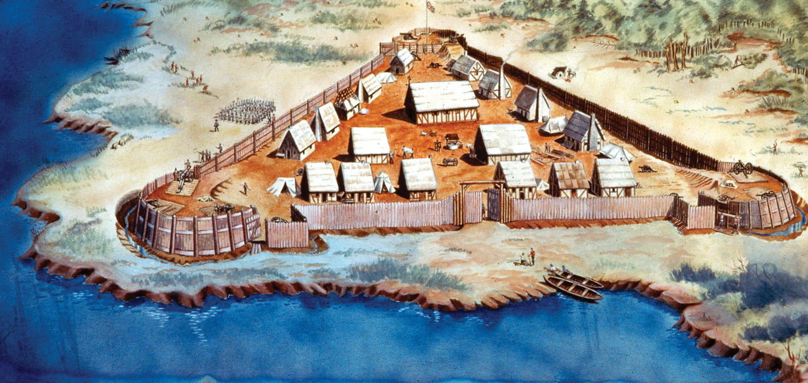  Illustration:  http://www.latinamericanstudies.org/united-states/Jamestown-fort.jpg
Define the term in your own words:  A crop grown for profit.  Cash crop |  | Definition:  Any crop that is considered easily marketable, as wheat or cotton.  A crop for direct sale in a market, as distinguished from a crop for use as livestock feed or for other purposes.
Examples:  - Coffee  - Tobacco  - Wheat  - Cotton |  | 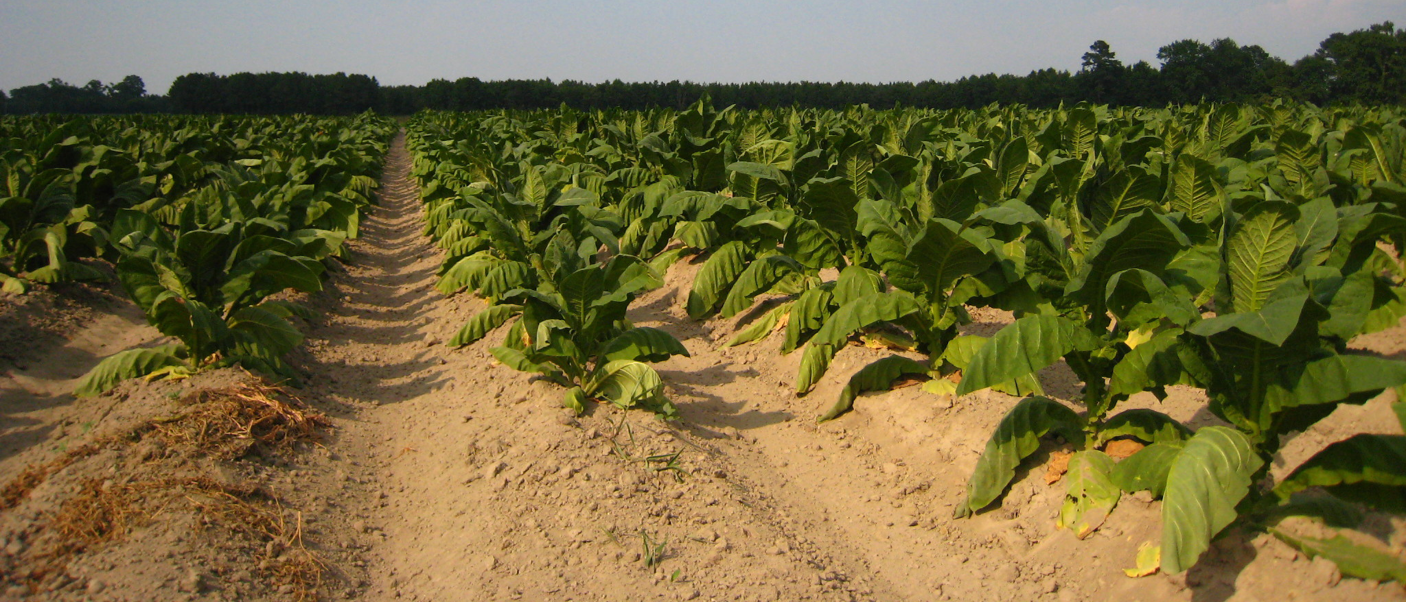  Illustration:  http://www.tobacco-news.net/wp-content/uploads/2010/12/tobacco-farmers.jpg
Define the term in your own words:  Something that relates to the wealth of a country or its economy.  Economic |  | Definition:  Something pertaining to the production, distribution, and use of income, wealth, and commodities.
Examples:  - Money  - Country’s wealth  - Use of income  - Land  - Resources  - Financial systems |  | Illustration:  http://www.therefinishingtouch.com/blog/uploaded_images/sell-into-recession-788635.JPG  
Define the term in your own words:  Someone who moves to another country for economic, political, or social reasons.  Immigrant |  | Definition:  A person who migrates to another country, usually for permanent residence.
Examples:  - Asian-Americans  - African-Americans  - Mexican-Americans |  | Illustration:  http://ijpc-cincinnati.org/sites/default/files/image-uploads/immigrant-students.jpg  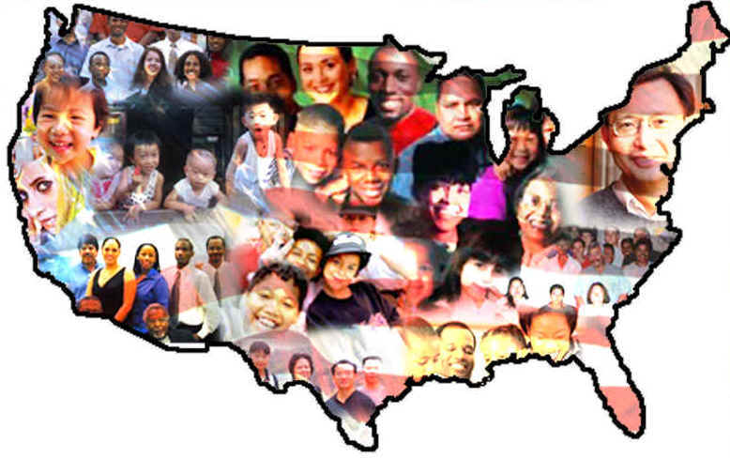
Define the term in your own words:  Someone who comes to a new country before everyone else  Pilgrim | Definition:  a newcomer to a region or place, especially to the western U.S
Examples:  - The Pilgrims  - The Puritans | Illustration:  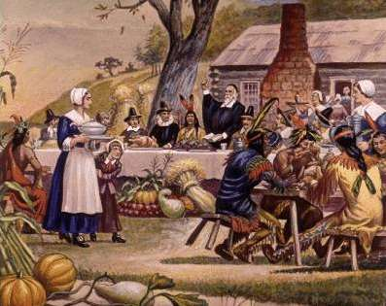  http://www.cpsd.us/tobin/directory/Grade3/Pilgrim_Webquest/Pilgrim_webquest_files/pilgrimsdinner2.jpg
Define the term in your own words:  Something that relates to politics.  Political | Definition:  Something of, pertaining to, or concerned with politics
Examples:  - Democratic Party vs. Republican Party  - Elections for Judges, President, Governor, Mayor, Senator, or Representatives  - Voting on laws  - Government | Illustration:    http://99problems.org/wp-content/uploads/2011/03/donkey_elephant-transparent.png
Define the term in your own words:  A person who very religious or good-natured.  Puritan | Definition:  A person who is strict in moral or religious matters, often excessively so.
Examples:  - Protestants from the Church of England  - Popes  - Priests  - Bishops  - Patriarchs  - Cardinals  - Primates | Illustration:  http://www.apuritansmind.com/wp-content/uploads/MiscImages/PuritanWorship.jpg 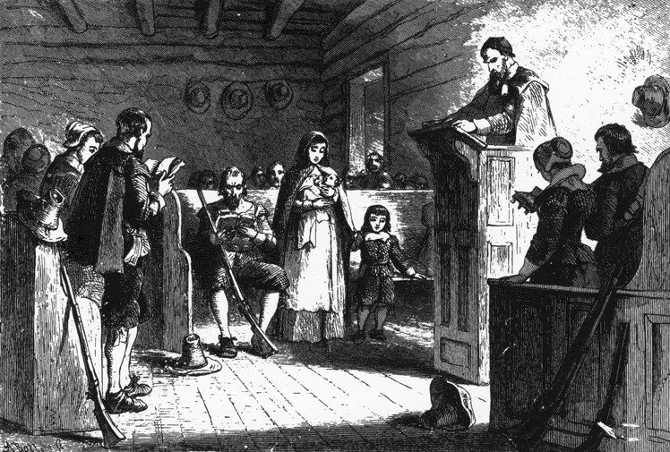
Define the term in your own words:  A section or area specific to a title.  Region | Definition:  An extensive, continuous part of a surface, space, or body.
Examples:  - Valleys  - Plains  - Mountains  - Lakes  - Bayous  - Hills  - Marshes | Illustration:  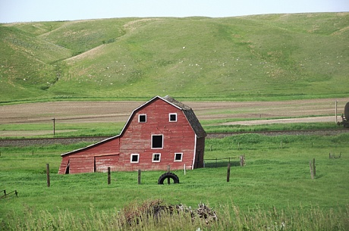  http://www.fema.gov/sites/default/files/styles/rotator_large/public/region_viii_photo_2.jpg
Define the term in your own words:  A form of government where representatives are elected which represent the country.  Representative Government | Definition:  Allows a country with many, many citizens, to be represented by a smaller group, which are the governmental representatives.
Examples:  - Texas’ Government  - United States Government  - San Antonio’s Government | Illustration:    http://www.fasttrackteaching.com/civics/review/CE2_Voting_Poster600g100.gif
Define the term in your own words:  The slave industry from the beginning of the New World to mid-19th century.  Slave Trade | Definition:  The business or process of procuring, transporting, and selling slaves, especially black Africans to the New World prior to the mid-19th century.
Examples:  - Selling slaves  - Transporting slaves  - Procuring slaves | Illustration:  http://www.discover-liverpool.com/UserFiles/ATH~Slave%20Ship%20Hold.jpg 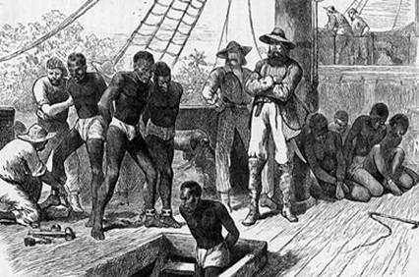
Define the term in your own words:  Things dealing with people and society.  Social | Definition:  Something of, pertaining to, connected with, or suited to polite or fashionable society.
Examples:  - Twitter  - Kik  - Instagram  - Facebook  - Youtube  - Communication | Illustration:    http://blogs.earthlink.net/wp-content/uploads/2013/04/social.media_.jpg
Define the term in your own words:  Something that covers or goes across the Atlantic Ocean.  Transatlantic | Definition:  Something crossing or reaching across the Atlantic.
Examples:  - Cruises  - Journeys across the Atlantic Ocean  - Flights over the Atlantic | Illustration:  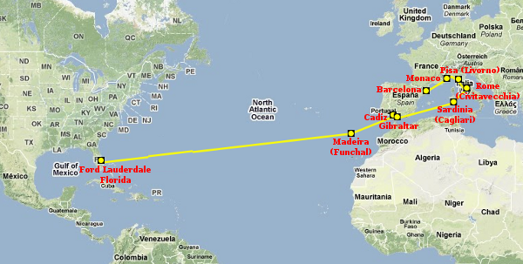  http://www.vagabondquest.com/wp-content/uploads/2010/03/Transatlantic-Cruise-Map-31.png

